Lab 7: Dimension Pattern, Hierarchy, and Dashboard
Name: Amisha Farhana Shaik

1. A star schema at a hospital is modeled as follows. (Dimension attributes not shown).
The hospital administration wants you to enhance the data warehouse to include the following information to support reporting. How would you extend the schema to include the additional attributes?
Hospital Admission Type – walk-in, Ambulance, transfer from another hospital;
Level of care – ICU, Med Floor, Ped ICU, Surgery
Outcome: Cure, Worsening, Mortality
Transfer to another hospital: Yes/No
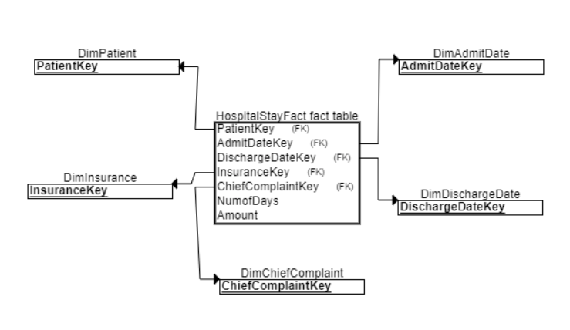
New Dimensions:
Admission Type Dimension (Admission Type Key, Admission Type (3 level of values))
Care Dimension (Care Key, Care Type (4 level of values))
Outcome Dimension (Outcome Key, Curse/worsen/mortality, transferred(yes/no))

2. The positions in an organization attribute includes levels such as CEO, VP, Director, Manager, and three levels of independent contributors (IC1, IC2, IC3). Here is a sample reporting structures. How would you model the hierarchy in a data warehouse?
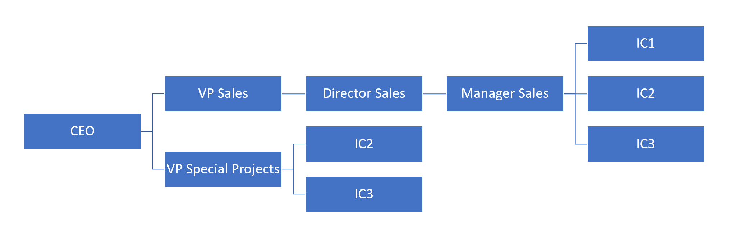
Position Key | Position Name
1 | CEO
2 | VP Sales
3 | VP Special Projects
4 | Director Sales
5 | Manager Sales
6 | IC1
7 | IC2
8 | IC3

Position Key | Position Name | Direct Parent Key (FK)
1 | CEO
2 | VP Sales | 1
3 | VP Special Projects | 1
4 | Director Sales | 2
5 | Manager Sales | 4
6 | IC1 | 5
7 | IC2
8 | IC3

Position Map Bridge Table

Parent Key (PK) | Child Key (PK) | Depth (Smallest Depth) | Highest Parent (Root Node) | Lowest Child (Leaf Node) | Percentage Ownership
1 | 1 | 0 | TRUE | FALSE
1 | 2 | 1 | TRUE | FALSE
….
1 | 7 | 2 | TRUE | FALSE
….
3 | 7 | 1 | FALSE | TRUE | 30%
3 | 3 | 0 | FALSE | FALSE
5 | 7 | 1 | FALSE | TRUE | 70%
3 | 8 | 1 | FALSE | TRUE | 50%
5 | 8 | 1 | FALSE | TRUE | 50%
5 | 5 | 0 | FALSE | FALSE
5 | 6 | 1 | FALSE | TRUE

3. Combine the Views and create a dashboard;
(1). Build a Dashboard and learn the lay outs;
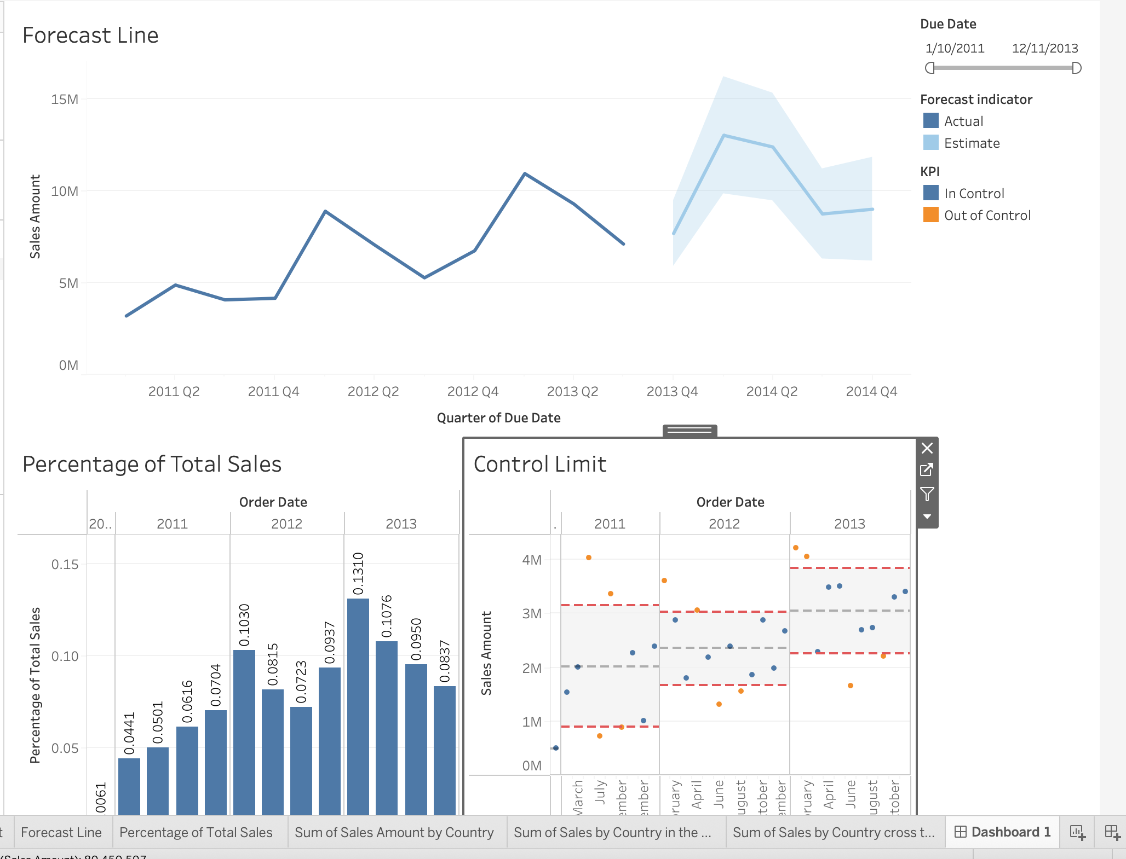
(2). Rearrange filters and legends: Float the Forecast indicator, and Highlight the items in the forecast indicator:
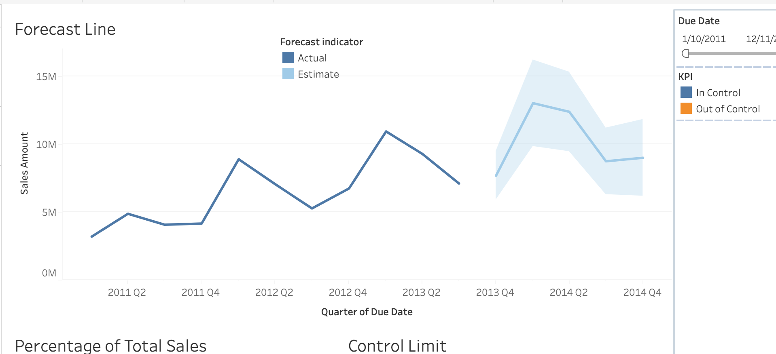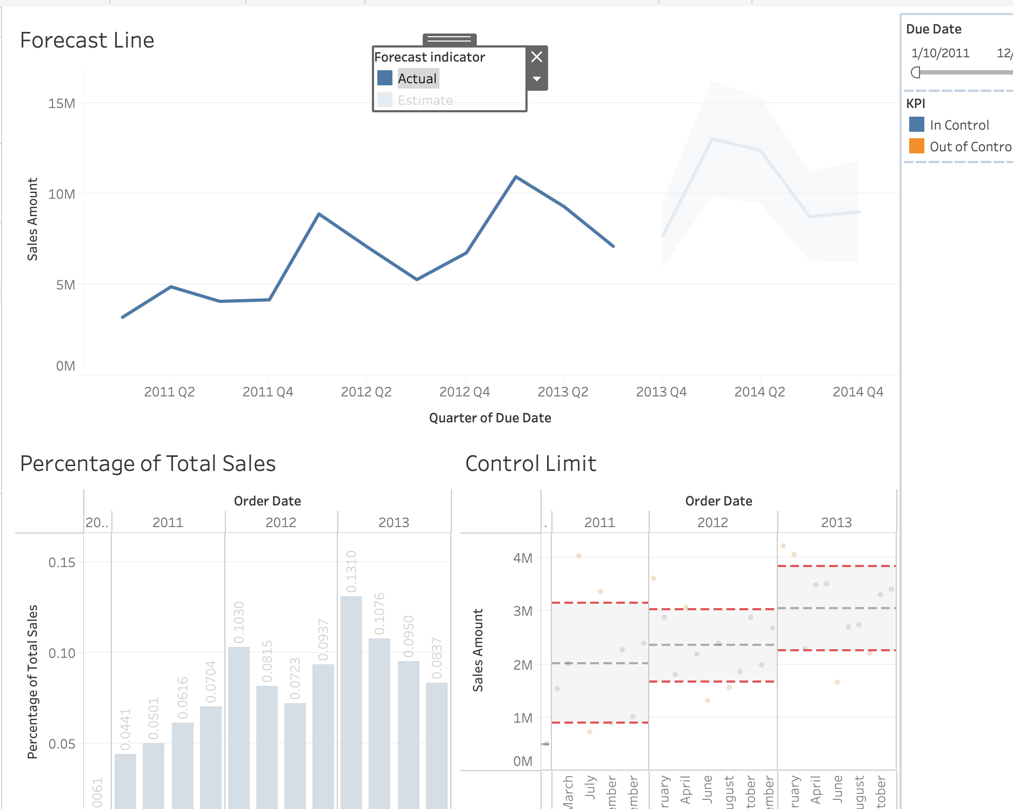
(3). Use a view as a filter: Use Percentage of Total Sales to filter the other two views;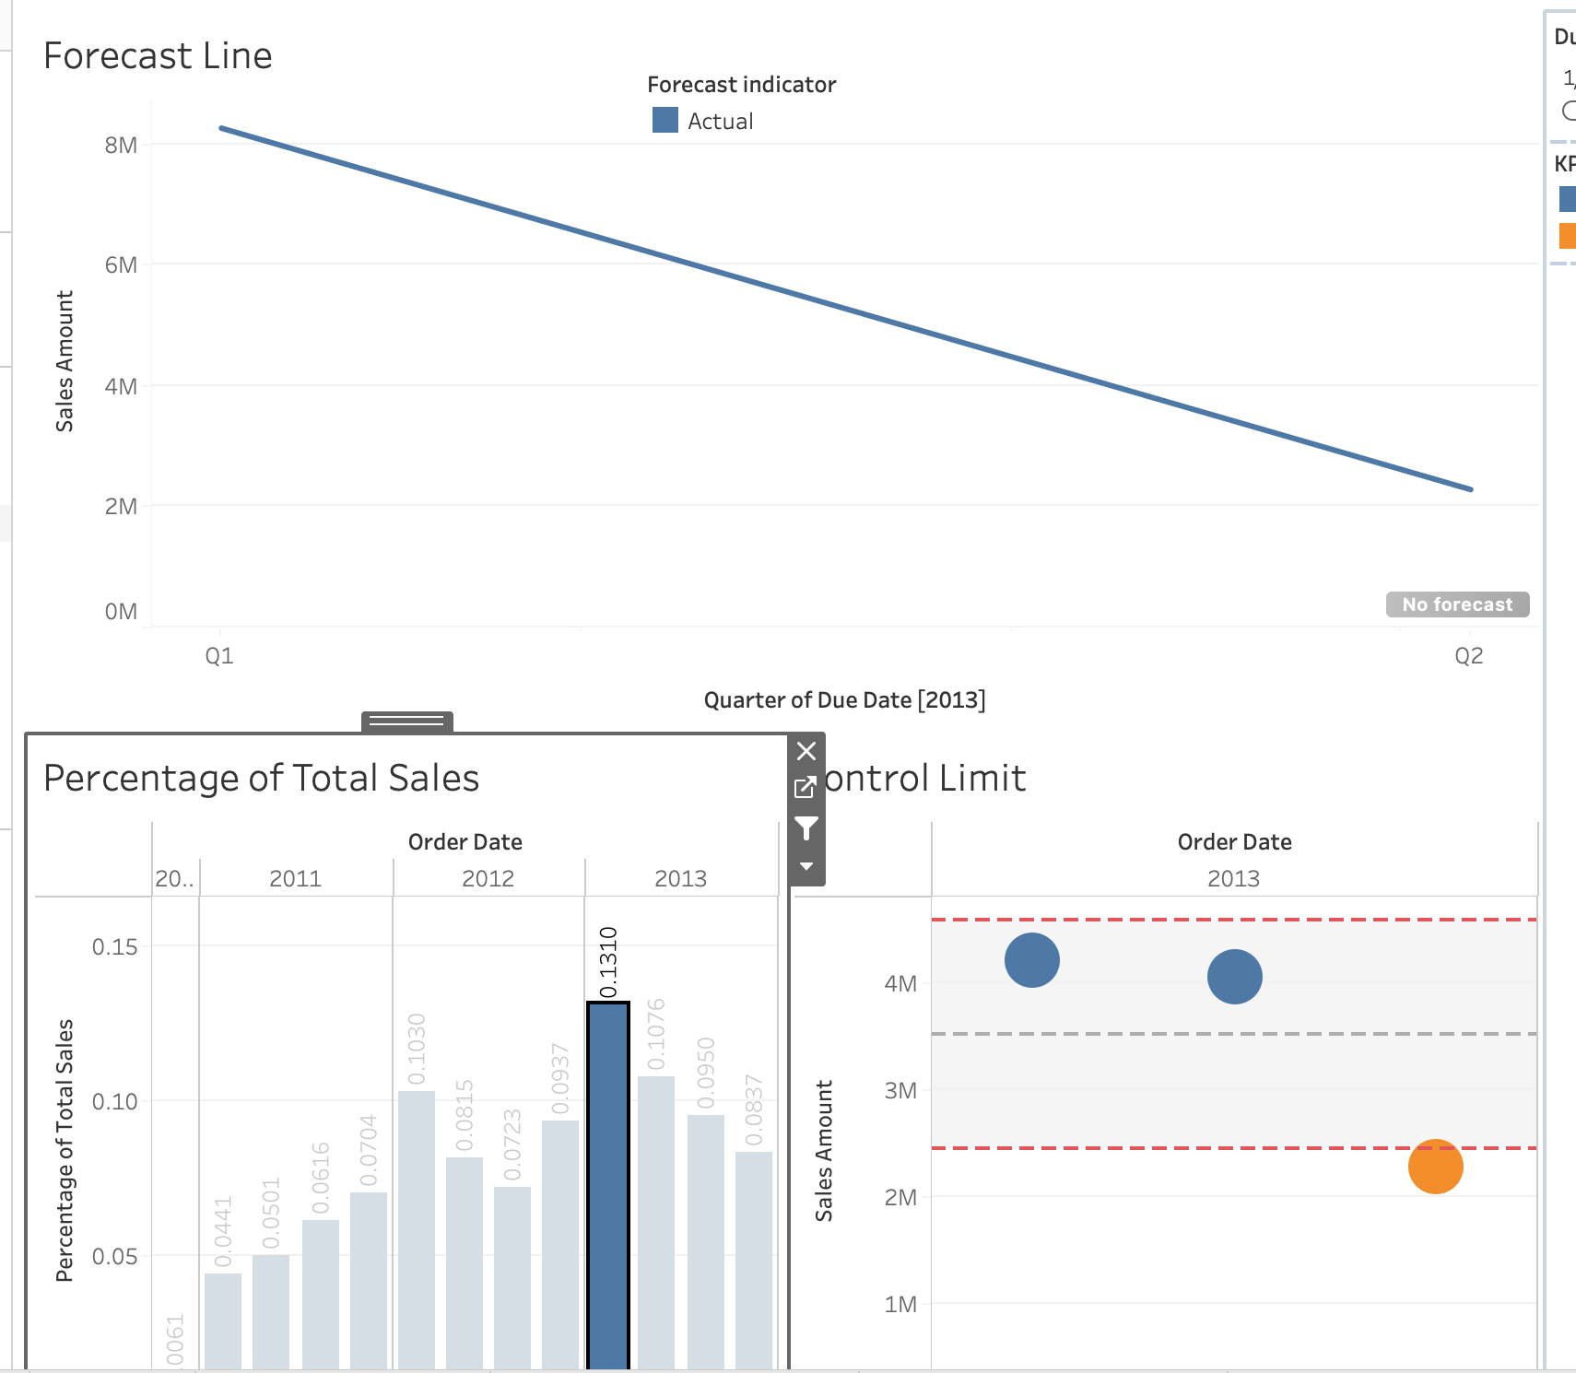
(4). Apply a filter to all worksheets: Apply due date filter to all the views in the data source;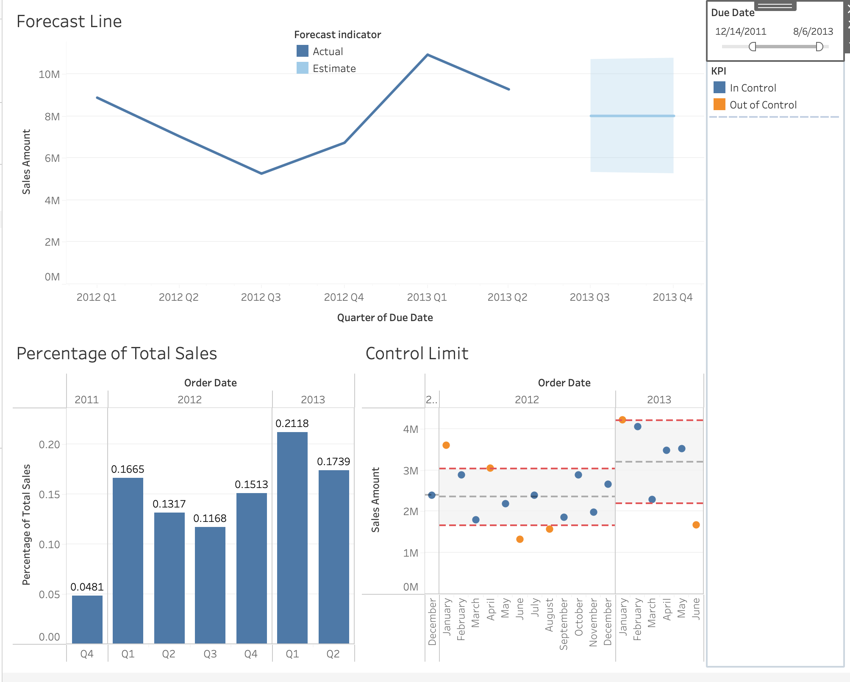
(5). Hide worksheets if you don’t need to show them to your final audience:
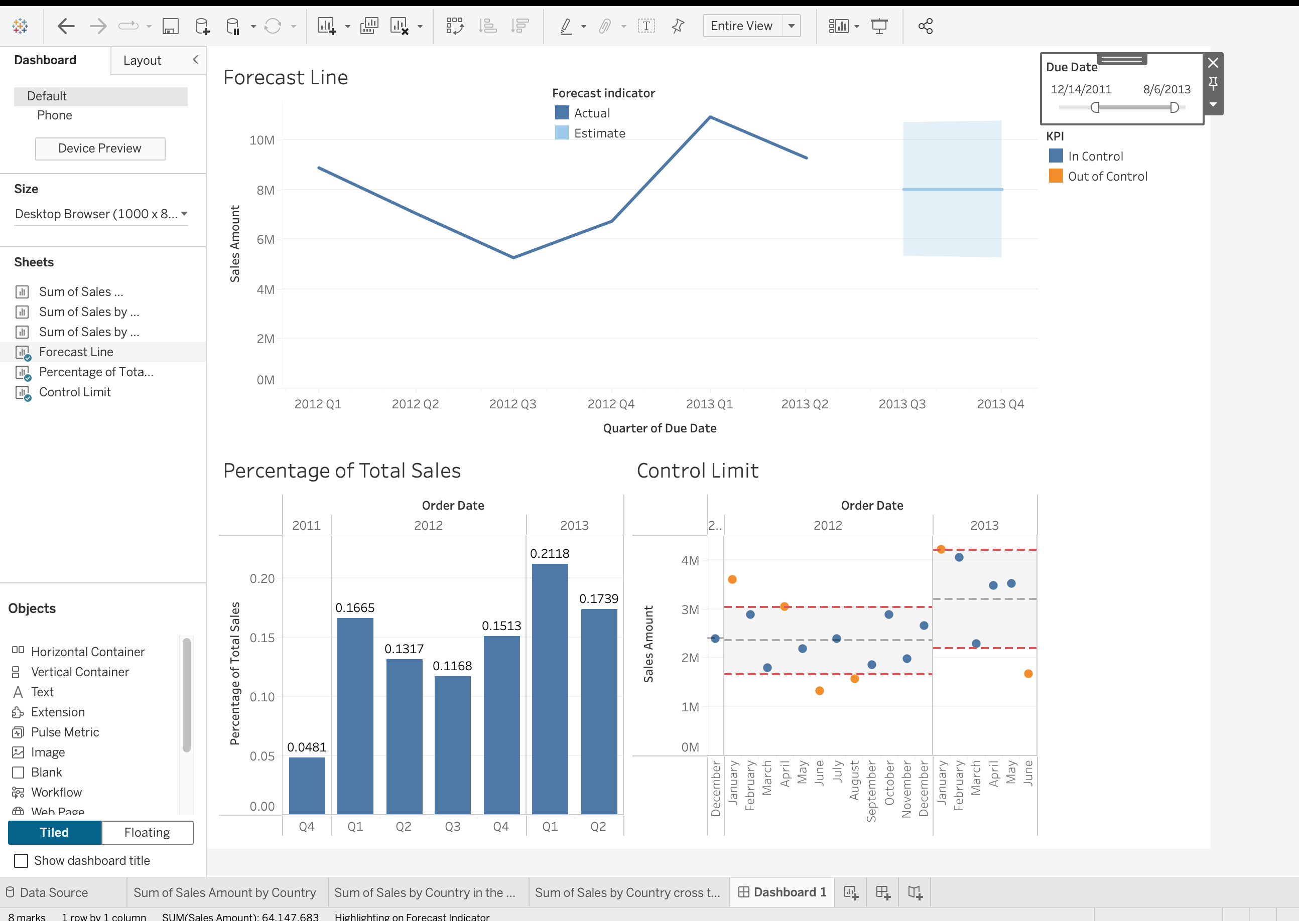

4. Add Actions for interactivity;
(1). Add highlight action: when you hover the points at control limit, highlight the corresponding columns at Percentage of Total Sales:
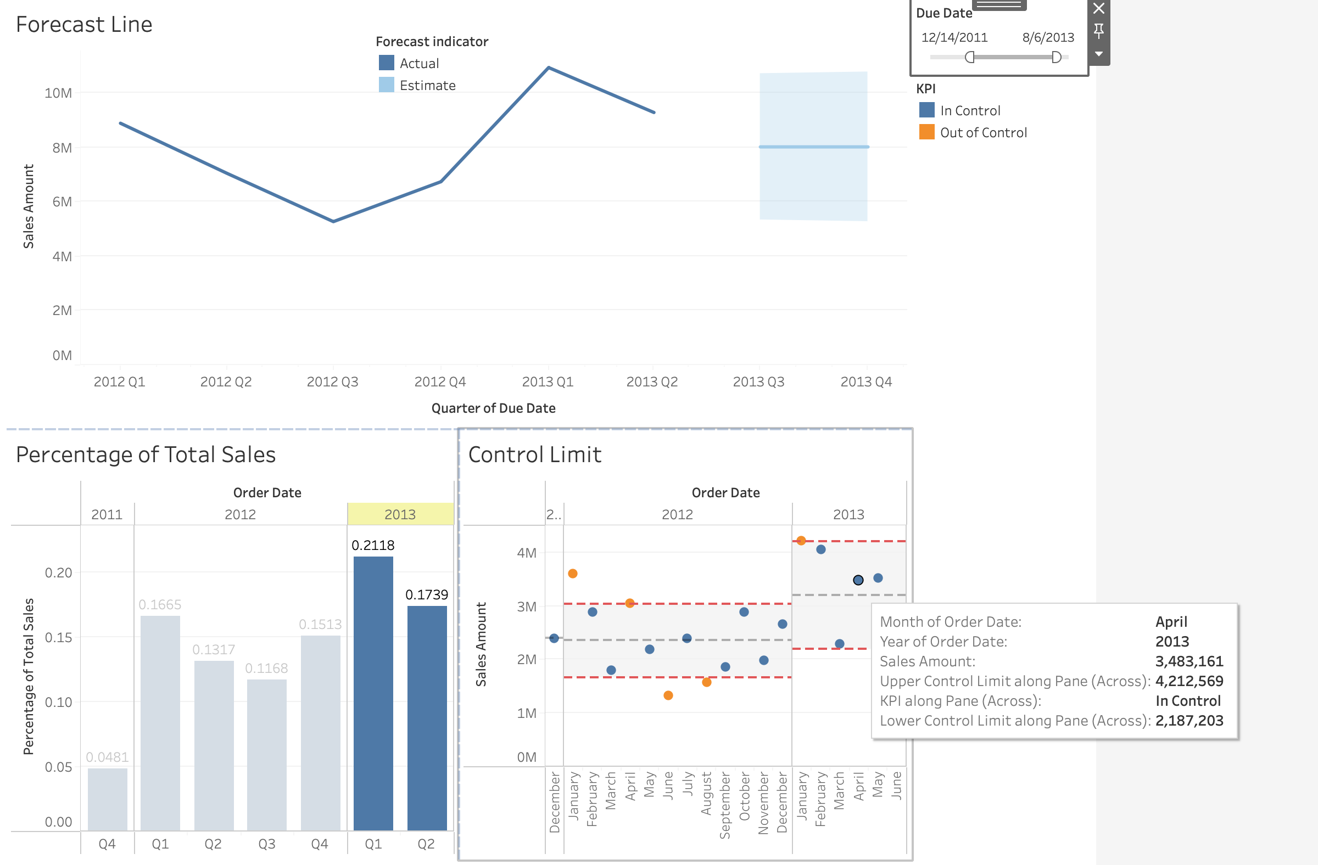
(2). Add hyperlinks action: add hyperlinks for the country in the view:

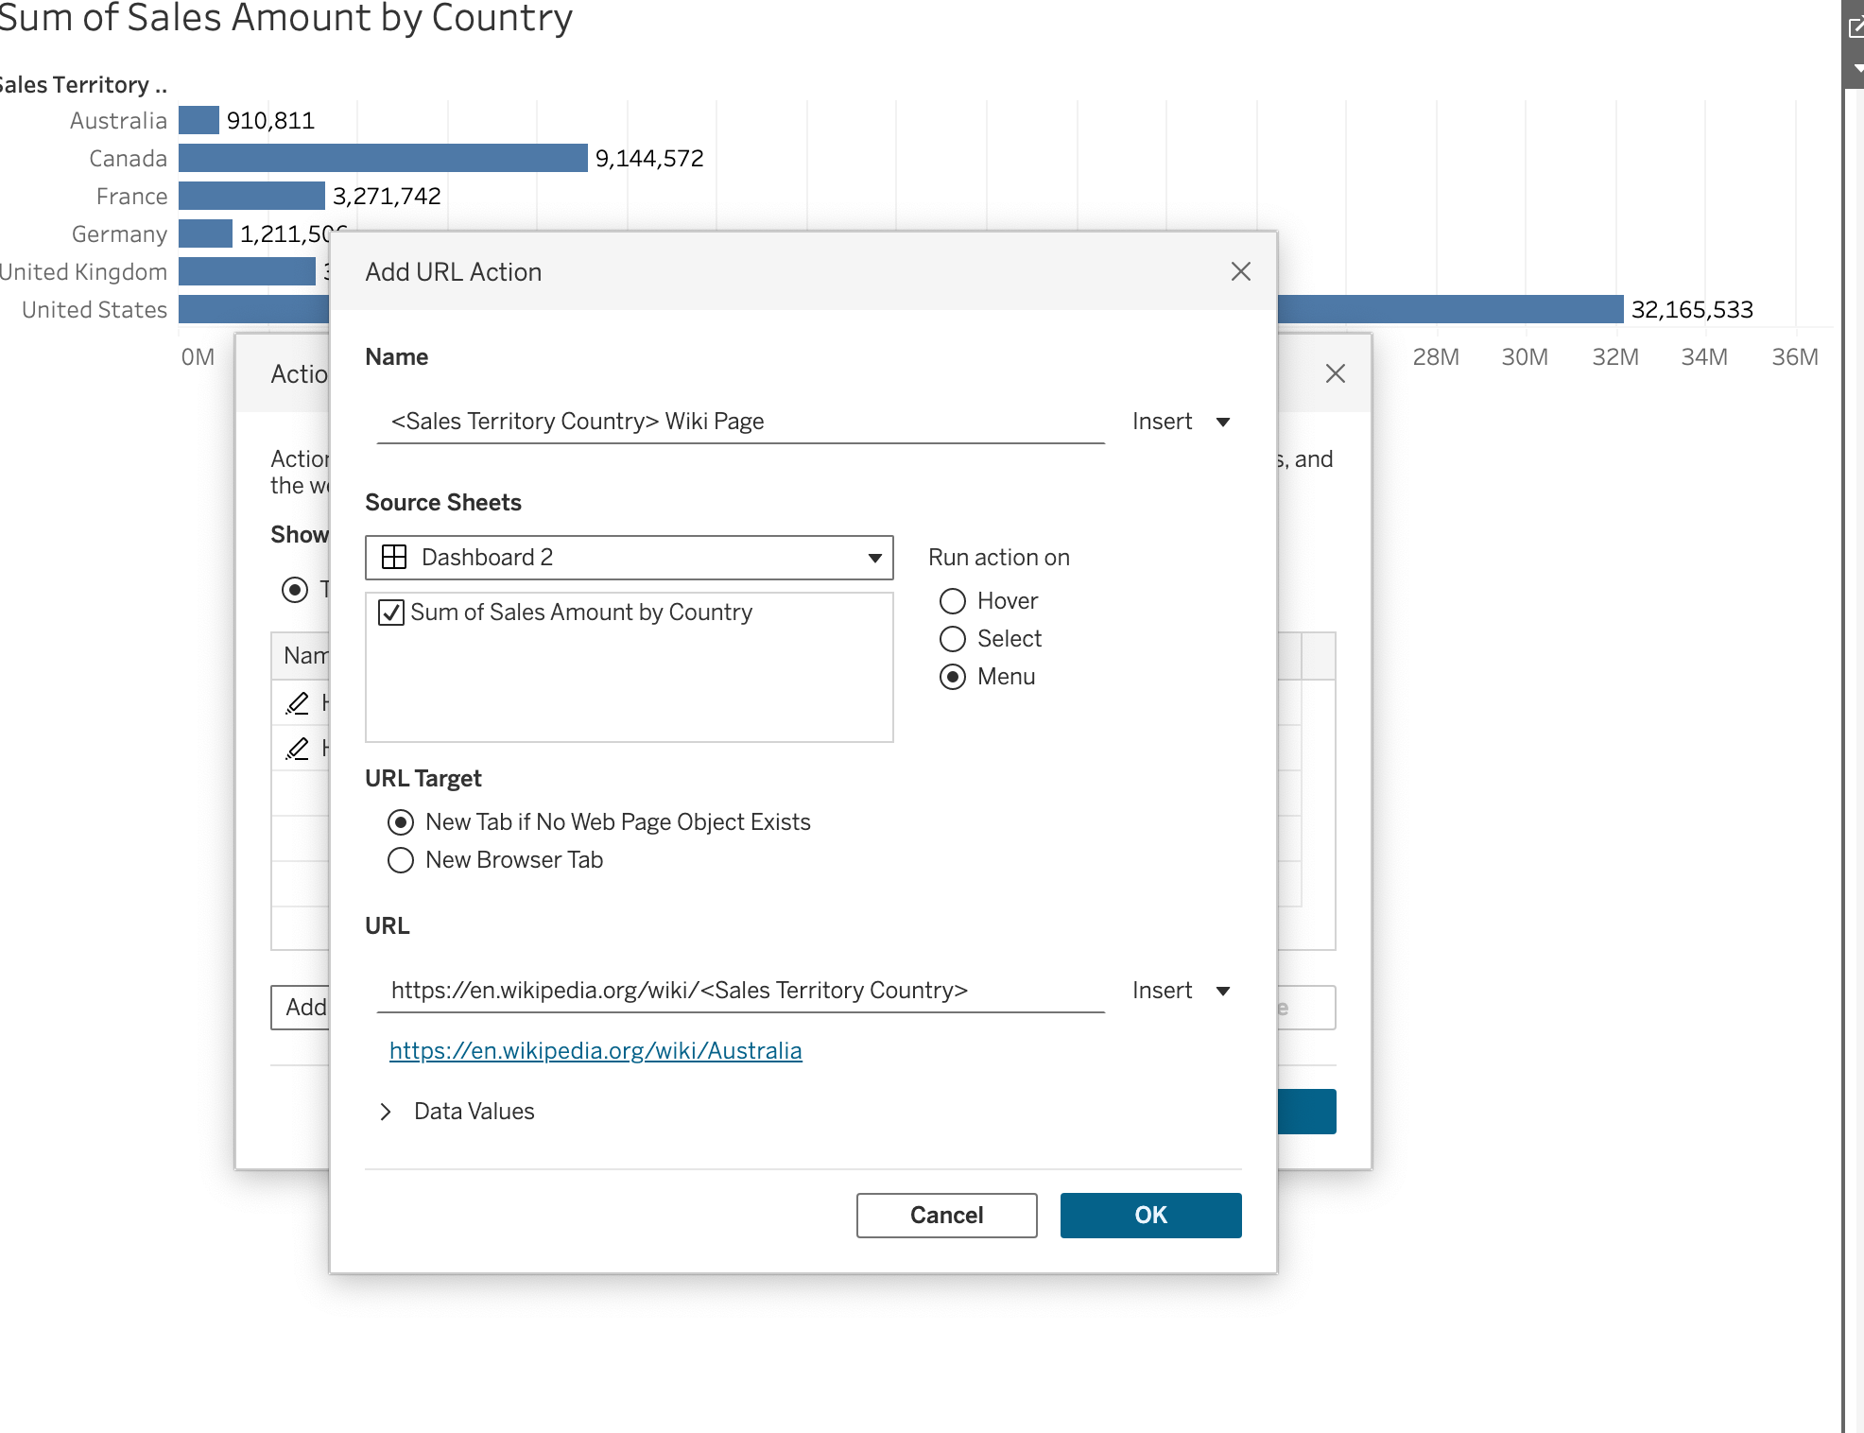
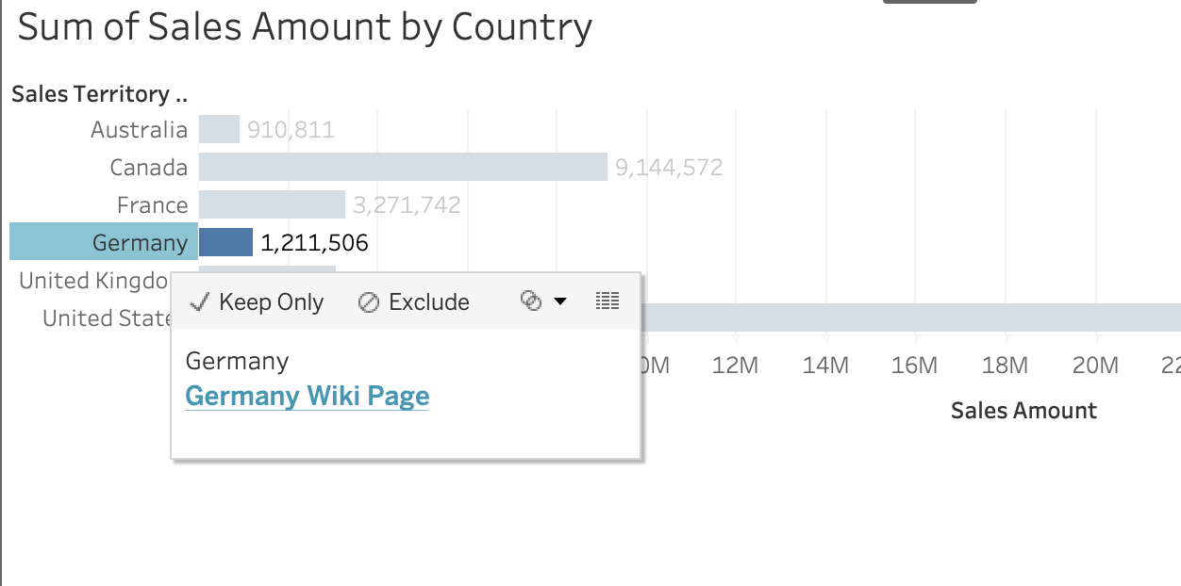
(3). Add filter action: exclude and hide the contents from one view until you click on other views;
